**JOBSHEET 7**

**OVERLOADING DAN OVERRIDING**

**Object Oriented Program**



Febrian Arka Samudra

2341720066 / 10

**STUDY PROGRAM D-IV INFORMATICS ENGINEERING**

**INFORMATICS TECHNOLOGY MAJOR**

**POLITEKNIK NEGERI MALANG**

Jl.Soekarno Hatta No.9,Jatimulyo, kec, Lowokwaru, Kota Malang, Jawa Timur 65141

* **Percobaan 1**

Class karyawan:

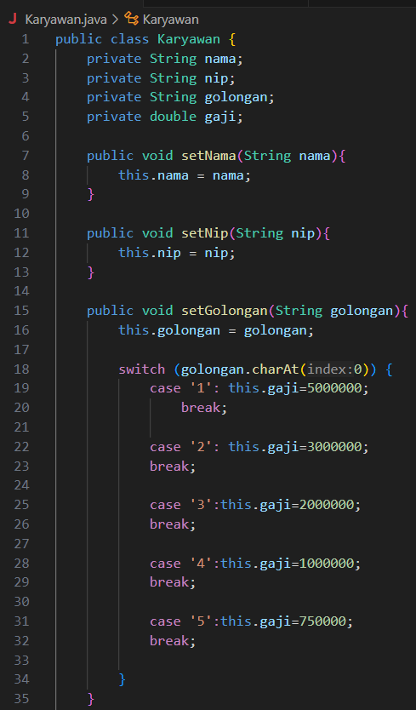 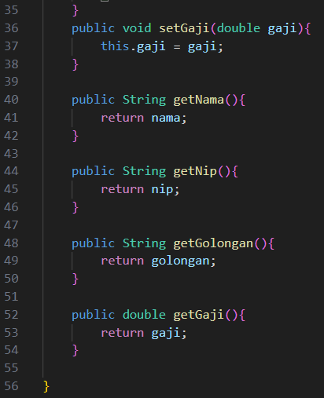

Class staff:

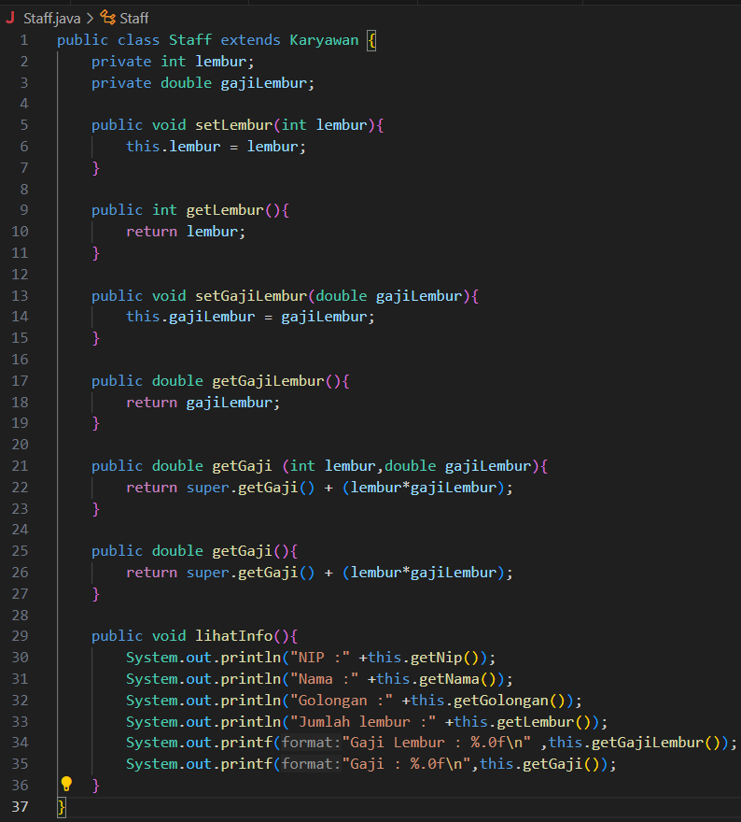

Class Manager:

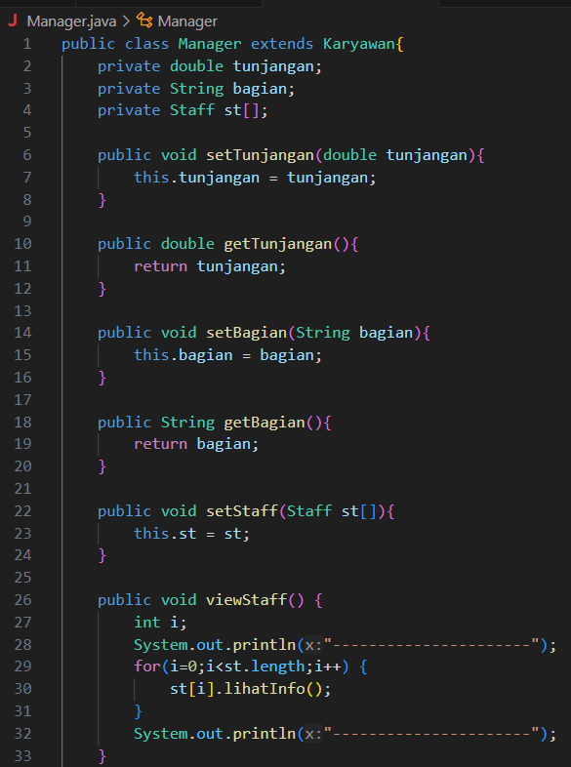 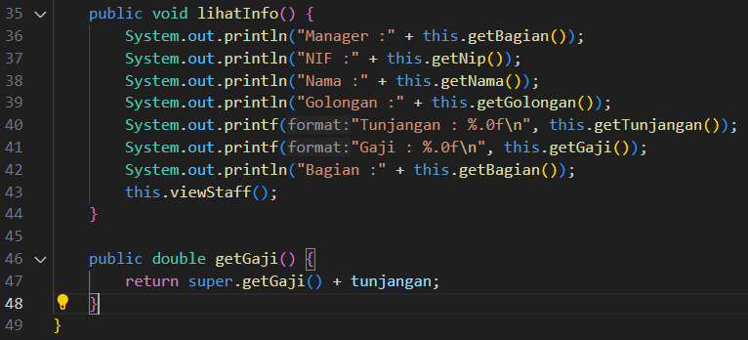

Main Class:

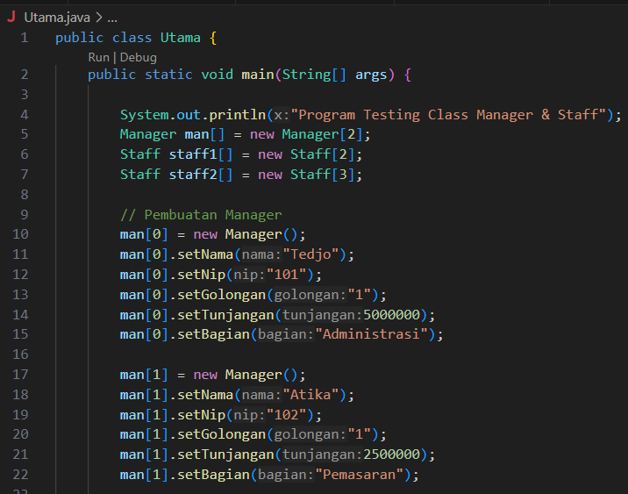 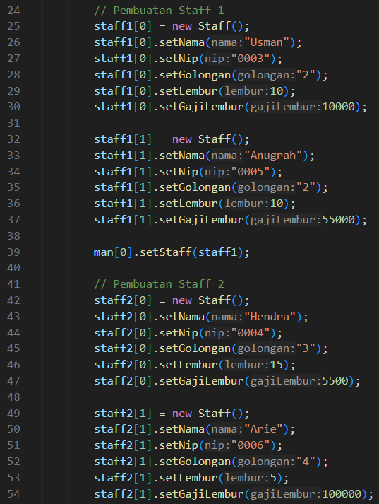

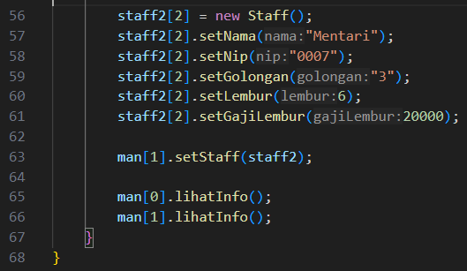

Output:

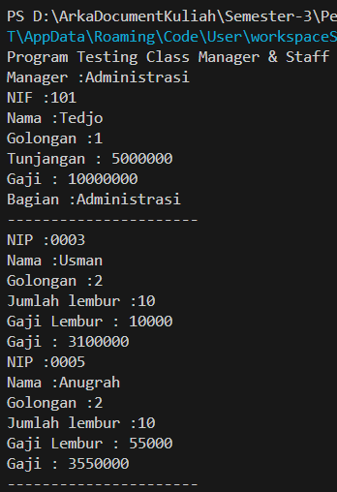

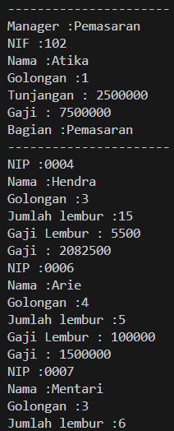



* **Exercise**

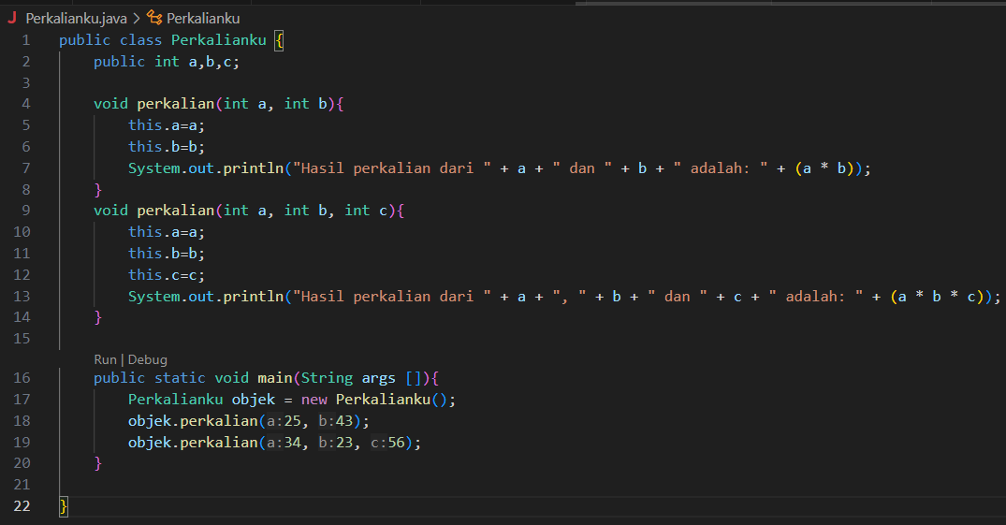

Output: 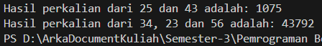

* 1. From the above source code, where is the overloading?

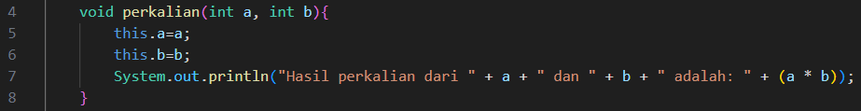

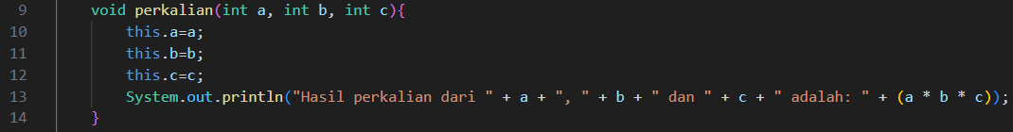

* 1. If there any overloading, how many parameters are different?
* The first perkalian method has 2 parameters:



* The second perkalian method has 3 parameters:



* The difference between the overloaded methods is 1 parameter. The first method accepts 2 parameters, while the second accepts 3.

•

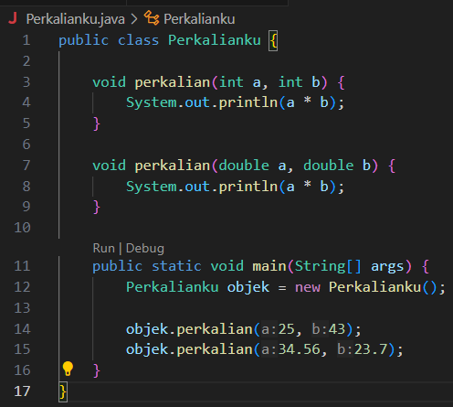

* 1. From the above source code, where is the overloading?

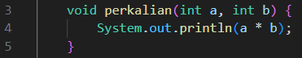

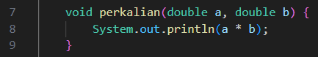

* 1. If there any overloading, how many parameters are different?
* No Different

•

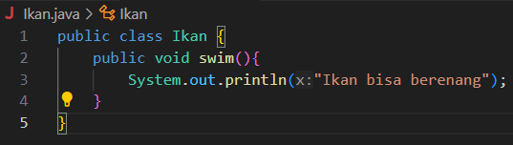

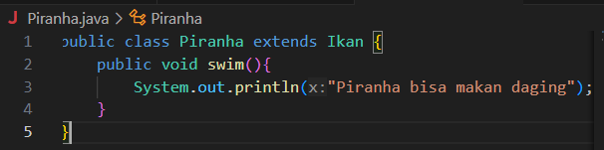

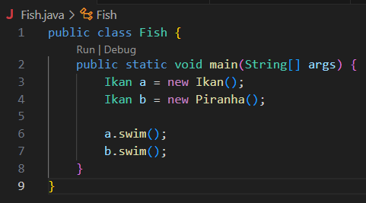

* 1. From the above source code, where is the overriding?



* class Piranha but extends it as an Ikan (as seen in the line Ikan b = new Piranha();), the overridden swim() method in the Piranha class will be called, not the one in the Ikan class.

So the overriding happens in the Piranha class with the swim() method

4.6 If there any overloading, how many parameters are different?

* In method overriding, the number of parameters must remain the same between the method in the superclass and the method in the subclass.
* method swim() in both the Ikan class and the Piranha class has no parameters. Therefore, the number of parameters is the same in both the superclass (Ikan) and the subclass (Piranha), meaning there are no differences in the number of parameters between the two methods.

1. **Task** 
   1. **Overloading**

Segitiga Class:

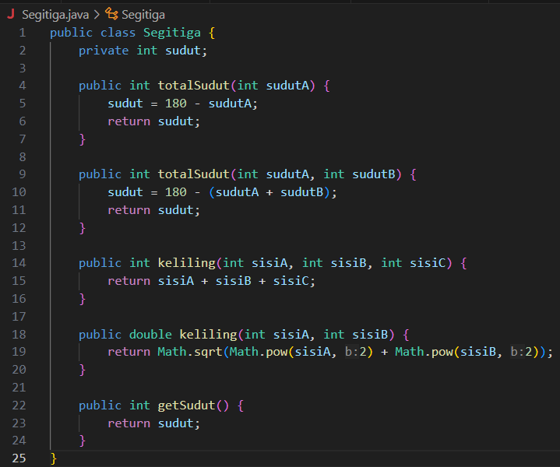

Main Segitiga:

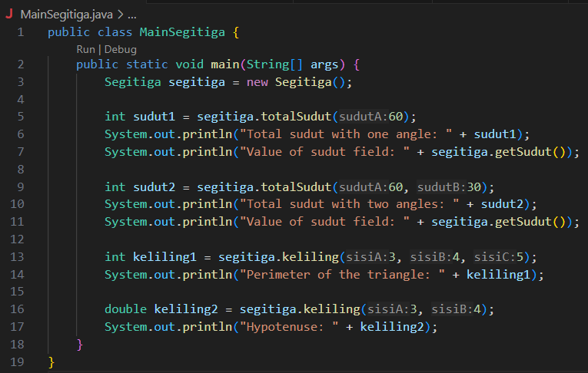

Output:

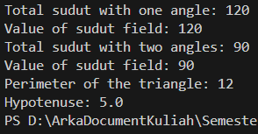

* 1. **Overriding**

Class Manusia:

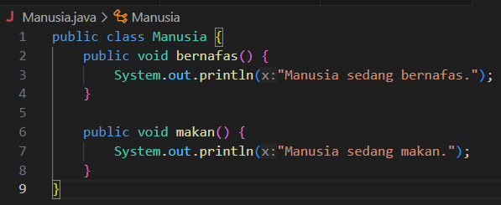

Class Mahasiswa:

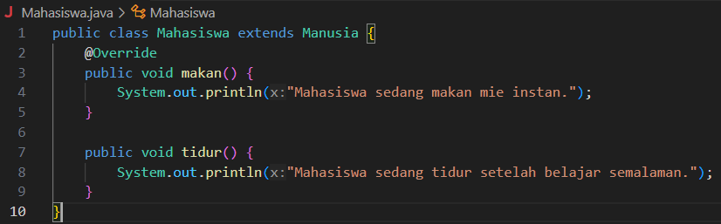

Class dosen:

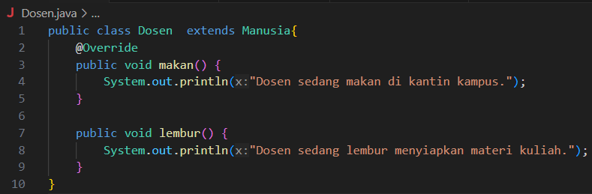

Main:

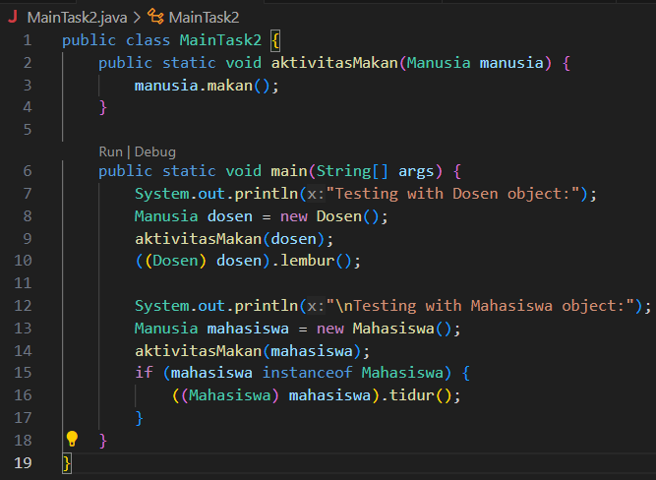

Output:

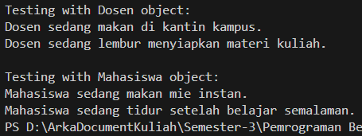

**Github:** [**https://github.com/FebrianArkaSamudra/Semester-3/tree/main/Pemrograman%20Berbasis%20Objek/Week7**](https://github.com/FebrianArkaSamudra/Semester-3/tree/main/Pemrograman%20Berbasis%20Objek/Week7)